**Module 14 Challenge - The Belly Button Biodiversity**

**SMU DS – Raj Agrawal**

**Submitted on: 09-AUG-2023**

**Repository – https://github.com/RajAgrawal99/SMU_DS_Bootcamp_March2023_RA.git**

**Folder – belly-button-challenge**

**Data source**

samples.json from the URL - <https://2u-data-curriculum-team.s3.amazonaws.com/dataviz-classroom/v1.1/14-Interactive-Web-Visualizations/02-Homework/samples.json>

Index.html

1. Use the D3 library to read in samples.json from the URL

**Example of index.html**

<!DOCTYPE html>

<html lang="en">

<head>

  <meta charset="UTF-8">

  <meta name="viewport" content="width=device-width, initial-scale=1.0">

  <meta http-equiv="X-UA-Compatible" content="ie=edge">

  <title>Bellybutton Biodiversity</title>

  <script src="https://d3js.org/d3.v7.min.js"></script>

  <script src="https://cdn.plot.ly/plotly-latest.min.js"></script>

  <link rel="stylesheet" href="https://maxcdn.bootstrapcdn.com/bootstrap/3.3.7/css/bootstrap.min.css">

</head>

<body>

  <div class="container-fluid">

    <div class="row">

      <div class="col-md-12 jumbotron text-center">

        <h1>Belly Button Biodiversity Dashboard</h1>

        <p>Use below interactive charts, to explore the dataset</p>

      </div>

    </div>

**Example of app.js**

// on page start...

d3.json("https://2u-data-curriculum-team.s3.amazonaws.com/dataviz-classroom/v1.1/14-Interactive-Web-Visualizations/02-Homework/samples.json").then(function (data) {

console.log(data);

1. **horizontal bar chart with a dropdown menu to display the top 10 OTUs found in that individual.**
   * Use sample_values as the values for the bar chart.
   * Use otu_ids as the labels for the bar chart.
   * Use otu_labels as the hovertext for the chart.

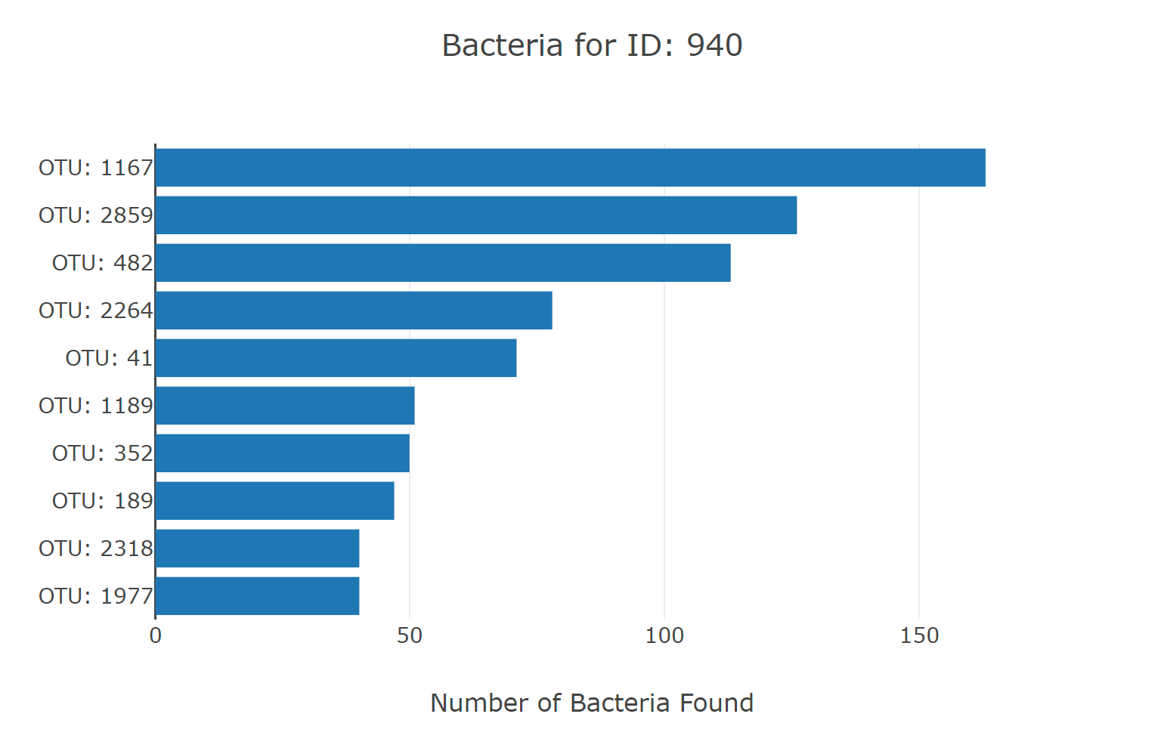

1. **bubble chart that displays each sample.**

* Use otu_ids for the x values.
* Use sample_values for the y values.
* Use sample_values for the marker size.
* Use otu_ids for the marker colors.
* Use otu_labels for the text values.

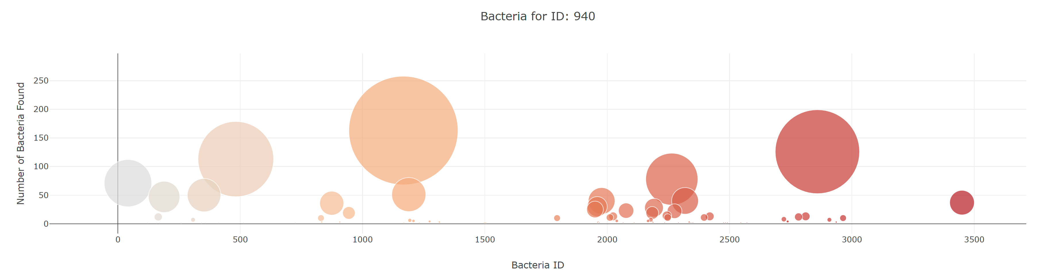

1. Display the sample metadata, i.e., an **individual's demographic information.**
2. Display **each key-value pair** from the metadata JSON object somewhere on the page.

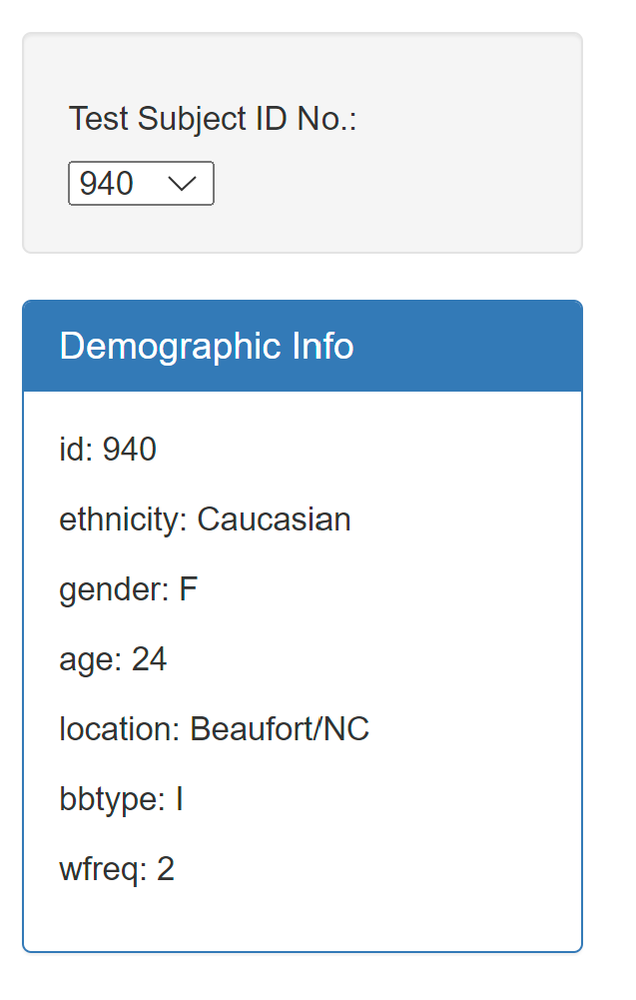

1. **An example dashboard is shown**



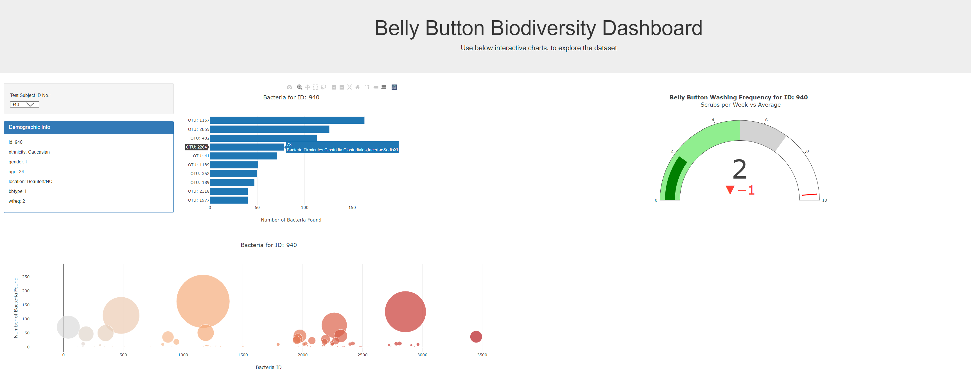

1. README.md file